
SIKSHA ‘O’ ANUSANDHAN
(Deemed to be University)
Faculty of Engineering & Technology (ITER)

Department of Computer Science and Engineering

Project Proposal Form
FINAL YEAR RESEARCH PROJECT-2026

SECTION: 2241033 GROUP NO: 14
PROJECT TITLE: Multimodal Depression Detection Using Speech And Linguistic Behaviour Analysis Across Conversational Phases
PROJECT ABSTRACT:
Depression is a serious mental health disorder that often remains undiagnosed due to lack of accessible and objective screening tools. Traditional diagnosis depends on questionnaires and clinical observation, which are time-consuming and subjective. This project proposes an automated multimodal depression detection system using speech and textual behavioural analysis from clinical interview recordings.
The system utilizes interview recordings from a psychological dataset and focuses only on participant responses. Each interview is divided into three conversational phases: beginning, middle, and end. From the speech signal, behavioural acoustic features such as pitch variation, speech energy, speaking rate, pause duration, and spectral characteristics are extracted to capture vocal indicators of depressive behaviour. Simultaneously, linguistic features are obtained from transcripts using contextual language representations generated by a pretrained language model.
Audio and text features are combined to form a multimodal representation and used to train machine learning classifiers for depression prediction. The system also evaluates depression detectability across conversational phases to analyze how behavioural indicators evolve during interaction.
The proposed method aims to provide a non-invasive, interpretable, and automated screening approach that can assist early mental health assessment. This work contributes to digital mental healthcare by studying both behavioural patterns and modality effectiveness rather than only maximizing classification accuracy

- SOFTWARE, HARDWARE OR METHODS/ALGORITHMS SPECIFICATIONS:
Software
- Python
- Librosa (audio processing)
- Scikit-learn (machine learning)
- Transformers / BERT (text embeddings)
- Pandas & NumPy (data handling)
- Matplotlib / Seaborn (visualization)
Hardware
- Standard PC/Laptop (8-16 GB RAM)
- No GPU required
Methods / Algorithms
- Speech activity detection and conversational segment selection
- Extraction of behavioural acoustic features (prosodic, temporal, and spectral characteristics)
- Contextual linguistic representation from transcripts
- Multimodal feature integration
- Evaluation of multiple supervised classification algorithms
- Cross-validation based performance assessment
- Model interpretation and behavioural analysis
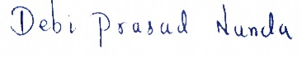
- NAME, REG. NO AND SIGNATURE OF GROUP MEMBERS:
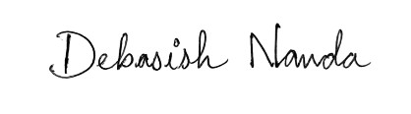
1) Debi Prasad Nanda (2241014018)
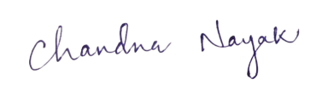
2) Debasish Nanda (2241014017)
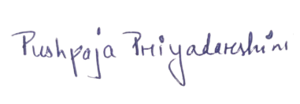
3) Chandna Nayak (2241014072)
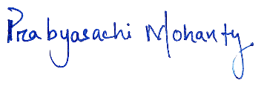
4) Pushpaja Priyadarshini (2241016474)
5) Prabyasachi Mohanty (2241013258)

- APPROVAL STATUS (To be filled in by the Section Coordinator of FRP):

……………………………… ……………………………… …………………………
Project Supervisor Section Coordinator, FRP FRP Coordinator

